**Q2. Create the following tables and perform the queries that follow.**

**College Apply**

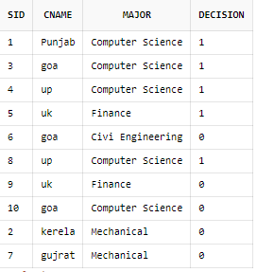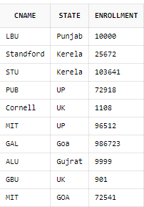

**Student**

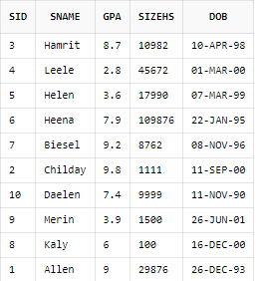

1. Select sname,dob from student;

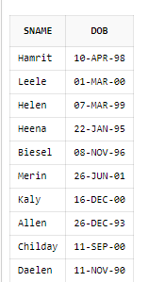

1. Select sname from student where gpa>3.7;

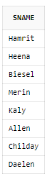

1. Select sname from student where sizeHS>=1000 AND DOB>'31-Dec-1996';

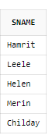

1. Select sname from student where GPA>2.9 AND GPA<3.9;



1. Select * from college where state='goa';

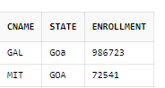

1. select * from student where gpa>2.0 AND gpa<3.5;

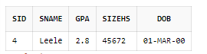

1. select * from student where dob>'01-JUL-1996' order by DOB ;

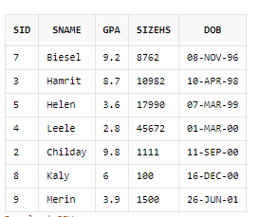

1. Select sid,cname,decision from apply where decision =1;

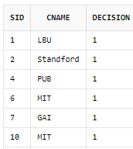

1. Select * from college where enrollment>10001;

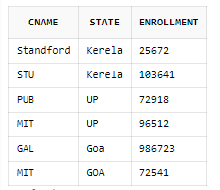

1. select * from college where NOT state='goa';

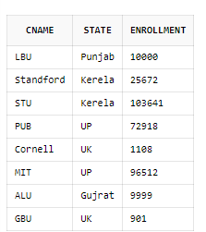

1. select sname from student where sizeHS>17000 AND GPA<3.8;



1. desc student;

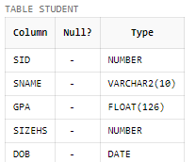

1. select * from student;

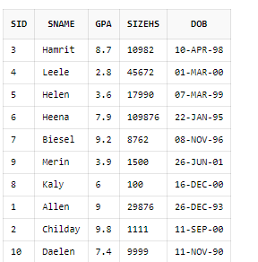

1. SELECT DISTINCT major from apply;

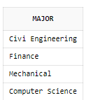

1. select sname from student where sname like '_____';



1. Select sname from student where sname like 'H____';



1. Select sname from student where sname like '__e_e%';

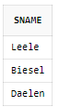

1. Select sname from student where sname like '%y';

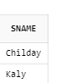

1. Select * from student order by GPA;

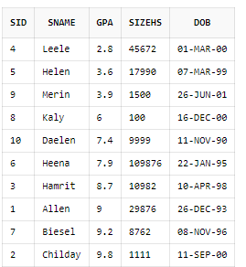

1. Select * from student order by GPA ,dob desc ;

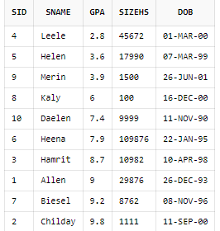

1. Select Sid from apply where cname='standford' OR cname='cornell' OR cname='mit';

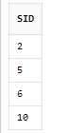

1. delete from apply where lower(cname)='standford';

Select * from apply;

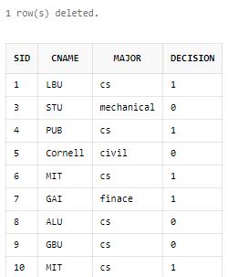

1. delete from college where lower(cname)='standford';

Select * from college;

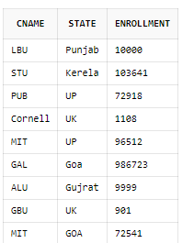

1. Update student set gpa=gpa*0.01+gpa;

Select * from student;

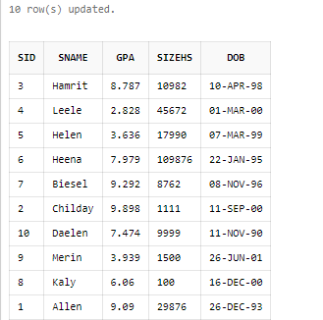

1. Update student set gpa=gpa*0.01+gpa where gpa>7 and sizehs>500;

Select * from student;

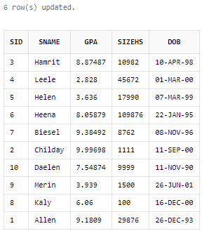

1. delete from student where GPA<3.2;

Select * from student;

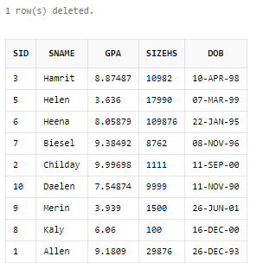

**Q3.Execute the following queries:**

**1.** **candidate (candidate_id, candidate_name, class, city, fee, DoB)**

a) create table candidate(

candidate_idint NOT NULL PRIMARY KEY,

candidate_namevarchar2(20),

classesint,

city varchar(20),

fee float,

DoB DATE);

desc candidate;

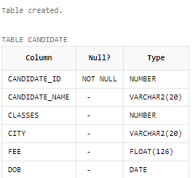

b) insert into candidate values(1001,'Ritik',8,'Dehradun',1888,'3-MAR-2000');

insert into candidate values(1002,'Suraj',9,'Haridwar',59000,'1-APR-1999');

insert into candidate values(1003,'Abhishek',11,'Dehradun',120000,'4-NOV-2002');

insert into candidate values(1004,'Rishabh',9,'Chamoli',86000,'9-DEC-2001');

insert into candidate values(1005,'Rakesh',10,'Roorkee',75000,'23-SEP-2003');

Select * from candidate;

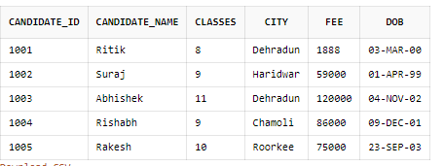

c) Select candidate_name,classes from candidate where city='dehradun' OR city='roorkee';

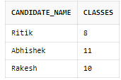

d) Select candidate_id from candidate where fee>50000 AND fee<85000;

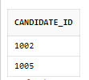

e) Select * from candidate where dob>'10-JAN-2000' order by dob desc;

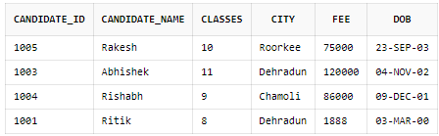

f) delete from candidate where candidate_name like '%b%k' ;



Select * from candidate;

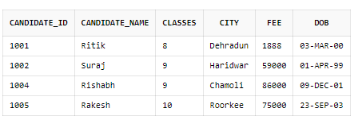

g) update candidate set fee=fee*0.01+fee where classes=9;



Select * from candidate;

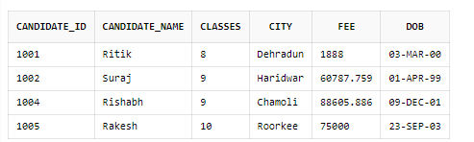

h) Alter table candidate add GPA float;



update candidate set gpa=9 where candidate_id=1001;

update candidate set gpa=8 where candidate_id=1002;

update candidate set gpa=7 where candidate_id=1004;

update candidate set gpa=6 where candidate_id=1005;

Select * from candidate;

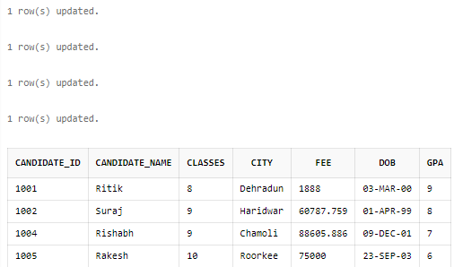

i)Select (candidate_name || ' having candidate id : ' || candidate_id || ' who studies in: '|| classes|| ' have GPA of: '|| GPA) as result from candidate ;

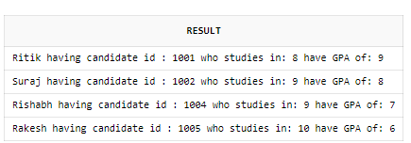

**2.** **Database Schema for a Employee-Detail**

**employee(emp_id, emp_name, dateofbirth, designation, department, salary, gender).**

a) create table employee(

emp_idint NOT NULL PRIMARY KEY,

emp_name varchar(20),

dateofbirth DATE,

designation varchar2(20),

department varchar(10),

salary float,

gender char);

desc employee;

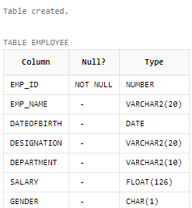

b) insert into employee values(1,'Akshay','20-JAN-1965','Tester','CS',80000,'M');

insert into employee values(2,'Abhishek','4-NOV-1980','Coderr','CS',99800,'M');

insert into employee values(3,'Rahul','11-MAR-1985','Manager','Management',120000,'M');

insert into employee values(4,'Ritika','20-DEC-1965','Tester','CS',90000,'F');

insert into employee values(5,'Anita','10-MAY-1965','Coder','CS',100000,'F');

select * from employee;

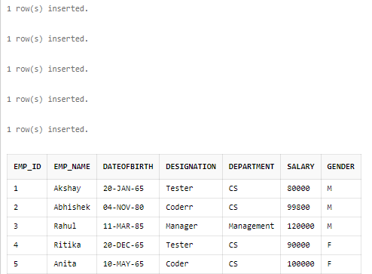

c) Select * from employee where NOT emp_name like '%b%';

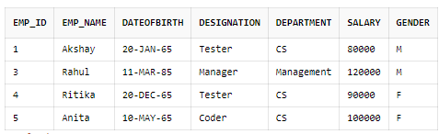

d)select max(salary) from employee ;

select min(salary) from employee ;

selectavg(salary) from employee ;

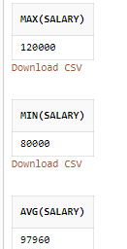

e) select count(department),department from employee group by department;

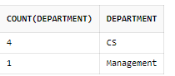

f) Select * from employee where gender='M' AND salary<(Select avg(salary)from employee where gender='F') ;

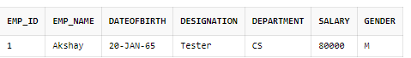

g) Select * from employee where dateofbirth=(select min(dateofbirth) from employee where dateofbirth<'1-JAN-1966' AND dateofbirth>'31-DEC-1964');

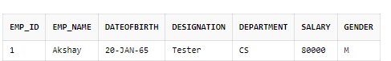

**3.** **Database Schema for a customer-sale scenario**

**Customer(Cust id : integer, cust_name: string)**

**Item(item_id: integer, item_name: string, price: integer)**

**Sale(bill_no: integer, bill_date: date, cust_id: integer, item_id: integer, qty_sold: integer)**

a) create table customer(

cust_idint NOT NULL PRIMARY KEY,

cust_namevarchar2(20));

desc customer;

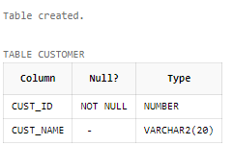

create table item(

item_idint NOT NULL PRIMARY KEY,

item_namevarchar2(20),

priceint);

desc item;

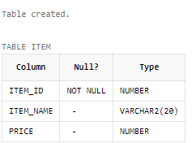

create table sale(

bill_noint NOT NULL PRIMARY KEY,

bill_date DATE,

cust_idint,

item_idint,

qy_soldint);

desc sale;

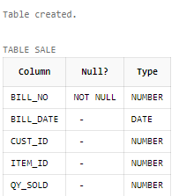

b) insert into customer values(1,'Allen');

insert into customer values(2,'Manan');

insert into customer values(3,'Rishabh');

insert into customer values(4,'Akshay');

insert into customer values(5,'Ayush');

insert into customer values(6,'Chinmay');

insert into customer values(7,'Harshit');

insert into customer values(8,'Sagar');

insert into customer values(9,'Aryan');

insert into customer values(10,'Yashasvi');

Select * from customer;

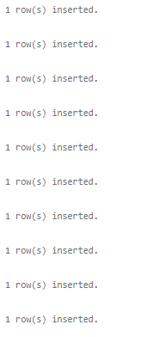

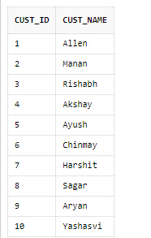

Insert into item values(1001,’TV’,52000);

insert into item values(1002,'Fridge',20000);

insert into item values(1003,'Washing Machine',18000);

insert into item values(1004,'Toaster',3000);

insert into item values(1005,'Charger',100);

insert into item values(1006,'Mobile',15000);

insert into item values(1007,'Oven',10000);

insert into item values(1008,'Cooler',12000);

insert into item values(1009,'Heater',800);

insert into item values(1010,'Geyser',12000);

Select * from item;

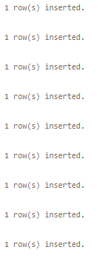

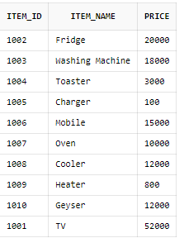

insert into sale values(2001,'01-NOV-2020',9,1003,1);

insert into sale values(2002,'01-NOV-2020',7,1004,4);

insert into sale values(2003,'01-NOV-2020',6,1006,2);

insert into sale values(2004,'09-SEP-2020',2,1009,3);

insert into sale values(2005,'01-NOV-2020',8,1001,1);

insert into sale values(2006,'07-SEP-2020',8,1008,2);

insert into sale values(2007,'01-NOV-2020',5,1001,3);

insert into sale values(2008,'08-SEP-2020',4,1003,4);

insert into sale values(2009,'01-NOV-2020',1,1001,1);

insert into sale values(2010,'01-JAN-2020',9,1005,2);

Select * from sale;

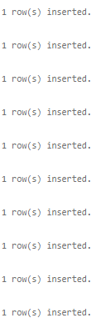

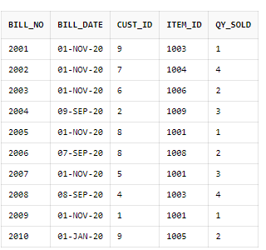

c) Select cust_name,item_name from customer Natural JOIN sale Natural Join item where bill_date='1-NOV-2020';

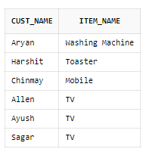

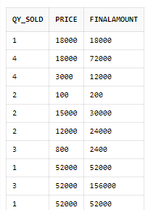d) Select qy_sold,price,(qy_sold*price)as finalamount from sale Natural Join item ;

e) Select cust_id,cust_name from customer Natural join sale natural join item where price>200;

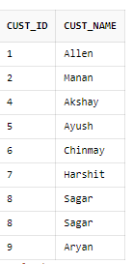

f) Select cust_name,qy_sold as bought_item from customer Natural JOIN sale;

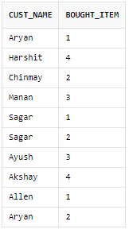

g) Select item_name from item Natural JOIN sale where cust_id=5 ;

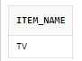

h) Select item_id,item_name from item Natural JOIN sale where bill_date='1-NOV-2020' ;

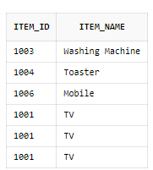

**4. Database Schema for a Student Library scenario**

**Student(Stud_no : integer, Stud_name: string)**

**Membership(Mem_no: integer, Stud_no: integer)**

**Book(book_no: integer, book_name:string, author: string)**

**Iss_rec(iss_no:integer, iss_date: date, Mem_no: integer, book_no: integer)**

1. Create the tables with the appropriate integrity constraints

create table Student(Stud_no int not null, Stud_name varchar2(20),primary key(Stud_no));

create table Membership(Mem_no: int not null, Stud_no int,primary key(Mem_no));

create table Book(book_no int not null, book_name varchar2(20), author varchar(15),primary key(book_no));

create table Iss_rec(iss_no int not null, iss_date date, Mem_no int, book_no int,primary key(iss_no));

2. Insert around 10 records in each of the tables

insert into student values(1,'Kartik');

insert into student values(2,'Vansh');

insert into student values(3,'Mehta');

insert into student values(4,'Tyagi');

insert into student values(5,'Aditya');

insert into student values(6,'Gautam');

insert into student values(7,'Siddharth');

insert into student values(8,'Megha');

insert into student values(9,'Nandini');

insert into student values(10,'Diamond');

insert into Membership values(01,1);

insert into Membership values(02,2);

insert into Membership values(03,3);

insert into Membership values(04,4);

insert into Membership values(05,5);

insert into Membership values(06,6);

insert into Membership values(07,7);

insert into Membership values(08,8);

insert into Membership values(09,9);

insert into Membership values(010,10);

insert into book values(001,'Harry Potter','JK Rowling');

insert into book values(002,'Goosebums','RL stine');

insert into book values(003,'The BFG','Roald Dahl');

insert into book values(004,'Death','Sadhguru');

insert into book values(005,'Its All In Your Head','Russ');

insert into book values(006,'Harry Potter','JK Rowling');

insert into book values(007,'Harry Potter','JK Rowling');

insert into book values(008,'Harry Potter','JK Rowling');

insert into book values(009,'Harry Potter','JK Rowling');

insert into book values(0010,'Harry Potter','JK Rowling');

insert into Iss_rec values(1,'31-jul-2016',1,1);  
insert into Iss_rec values(2,'31-aug-2018',2,2);  
insert into Iss_rec values(3,'15-jan-2016',3,3);

insert into Iss_rec values(4,'3-dec-2019',4,4);

insert into Iss_rec values(5,'6-mar-2020',5,5);

insert into Iss_rec values(6,'24-jul-2019',6,6);

insert into Iss_rec values(7,'1-oct-2021',7,7);

insert into Iss_rec values(8,'17-apr-2016',8,8);

insert into Iss_rec values(9,'3-feb-2021',9,9);

insert into Iss_rec values(10,'21-jun-2017',10,10);

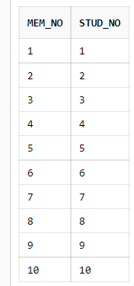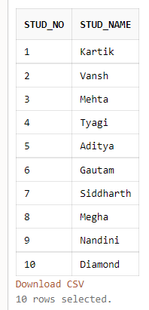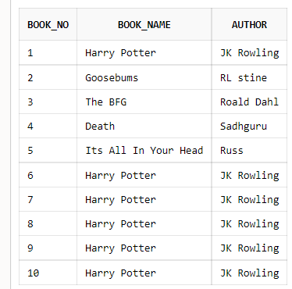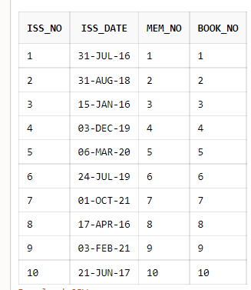

3. List all the student names with their membership numbers.

select stud_name,mem_no from student natural join membership;

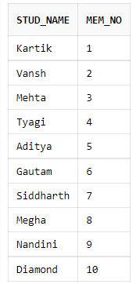

4. List all the issues for the current date with student and Book names

select stud_name,book_name from ((iss_rec natural join book)natural join student)natural join membership

where iss_date=to_char(sysdate)

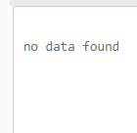

5. List the details of students who borrowed book whose author is ‘Sadhguru’.

select * from student where stud_no in(select stud_no from membership where mem_no in (select mem_no from iss_rec where book_no in(select book_no from book where author='Sadhguru')));

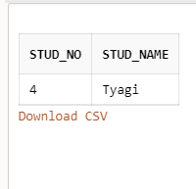

6. Give a count of how many books have been bought by each student

select s.stud_no, count(i.book_no) from student s,membership m, book b, iss_rec i

where s.stud_no=m.stud_no and b.book_no=i.book_no group by s.stud_no ;

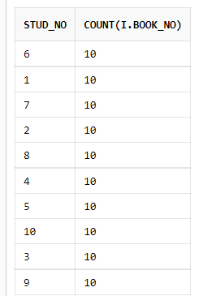

7. Give a list of books taken by student with stud_no as 5-:

select book_name from book where book_no in (select book_no from iss_rec where mem_no in(select mem_no from membership where stud_no in(select stud_no from student where stud_no=5)));

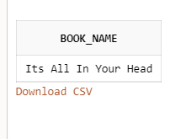

8. List the book details which are issued as of today.

delete from book where book_no in (select book_no from iss_rec where iss_date=to_char(sysdate));

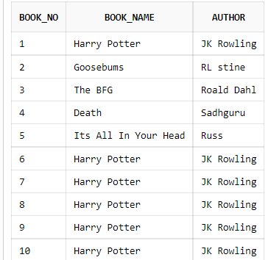

**5) Database Schema for a Employee-pay scenario**

**employee(emp_id : integer, emp_name: string)**

**department(dept_id: integer, dept_name:string)**

**paydetails(emp_id : integer, dept_id: integer, basic: integer, deductions: integer, additions: integer, DOJ: date)**

**payroll(emp_id : integer, pay_date: date)**

a) create table employee(

emp_idint NOT NULL PRIMARY KEY,

emp_namevarchar2(20));

desc employee;

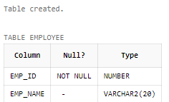

create table department(

dept_idint NOT NULL PRIMARY KEY,

dept_namevarchar2(20));

desc department;

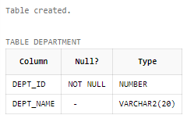

create table paydetails(

emp_idint,

dept_idint,

basicint,

deductionsint,

additionsint,

doj DATE);

descpaydetails;

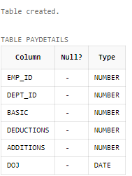

create table payroll(

emp_idint,

pay_date DATE);

desc payroll;

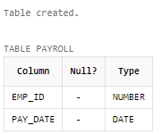

b) insert into employee values(1,'Abhishek');

insert into employee values(2,'Akshat');

insert into employee values(3,'Harshit');

insert into employee values(4,'Ayush');

insert into employee values(5,'Sagar');

insert into employee values(6,'Chinmay');

insert into employee values(7,'Manan');

insert into employee values(8,'Aryan');

insert into employee values(9,'Yashasvi');

insert into employee values(10,'Aman');

Select * from employee;

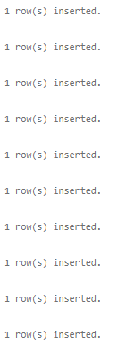

insert into department values(101,'Mechanical');

insert into department values(102,'Telecom');

insert into department values(103,'Civil');

insert into department values(104,'CS');

insert into department values(105,'Management');

insert into department values(106,'Helping');

insert into department values(107,'Electrical');

insert into department values(108,'Plumbing');

insert into department values(109,'Accounts');

insert into department values(110,'HR');

Select * from department;

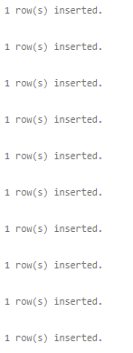

insert into paydetails values(5,110,110000,10000,5000,'3-MAR-2000');

insert into paydetails values(6,109,76000,5000,500,'1-DEC-1999');

insert into paydetails values(1,110,110000,9000,1000,'31-MAR-1998');

insert into paydetails values(2,106,12000,1100,200,'13-OCT-2000');

insert into paydetails values(9,106,12000,5000,100,'11-MAR-1965');

insert into paydetails values(10,108,11000,999,900,'4-JAN-1970');

insert into paydetails values(3,109,76000,8000,1000,'9-JUN-1999');

insert into paydetails values(8,104,90000,7700,400,'18-NOV-2003');

insert into paydetails values(4,104,90000,1112,900,'1-FEB-2008');

insert into paydetails values(7,104,90000,9998,1000,'9-MAY-2005');

Select * from paydetails;

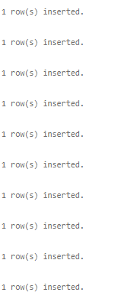

insert into payroll values(1,'1-JAN-2022');

insert into payroll values(2,'5-JAN-2022');

insert into payroll values(3,'9-JAN-2022');

insert into payroll values(4,'7-JAN-2022');

insert into payroll values(5,'1-JAN-2022');

insert into payroll values(6,'1-JAN-2022');

insert into payroll values(7,'1-JAN-2022');

insert into payroll values(8,'31-DEC-2021');

insert into payroll values(9,'31-DEC-2021');

insert into payroll values(10,'1-JAN-2022');

Select * from payroll;

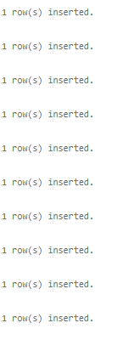

c) Select * from employee, paydetails,department where employee.emp_id=paydetails.emp_id and department.dept_id=paydetails.dept_id order by dept_name;

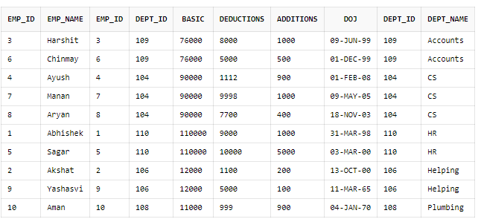

d) Select emp_name from employee NAtural JOIN paydetails where doj>'1-JAN-1998' ;

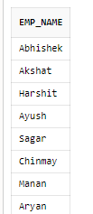

e) Select * from employee Natural Join paydetails where basic>10000 and basic<20000;

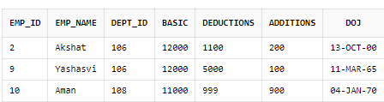

f) Select department.dept_id,count(employee.emp_id) from paydetails,employee,department where department.dept_id=paydetails.dept_id and employee.emp_id=paydetails.emp_id group by department.dept_id;

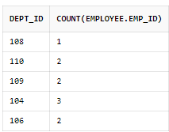

g) Select emp_name from employee Natural join paydetails where (basic-deductions+additions)>10000;

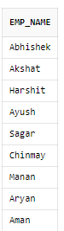

h) Select * from employee Natural Join paydetails Natural JOIN department Natural JOIN payroll where emp_id=5;

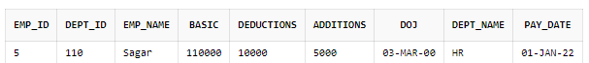

6.Database Schema for a Video Library scenario

**Customer(cust_no: integer,cust_name: string)**

**Membership(Mem_no: integer, cust_no: integer)**

**Cassette(cass_no:integer, cass_name:string, Language: String)**

**Iss_rec(iss_no: integer, iss_date: date, mem_no: integer, cass_no: integer)**

1. Create the tables with the appropriate integrity constraints-

Customer(cust_no: integer,cust_name: string)

Membership(Mem_no: integer, cust_no: integer)

Cassette(cass_no:integer, cass_name:string, Language: String)

Iss_rec(iss_no: integer, iss_date: date, mem_no: integer, cass_no: integer)

2. Insert around 10 records in each of the tables-:

insert into customer values(1,'Kartik');

insert into customer values(2,'Vansh');

insert into customer values(3,'Mehta');

insert into customer values(4,'Tyagi');

insert into customer values(5,'Aditya');

insert into customer values(6,'Gautam');

insert into customer values(7,'Siddharth');

insert into customer values(8,'Megha');

insert into customer values(9,'Nandini');

insert into customer values(10,'Diamond');

insert into Membership values(01,1);

insert into Membership values(02,2);

insert into Membership values(03,3);

insert into Membership values(04,4);

insert into Membership values(05,5);

insert into Membership values(06,6);

insert into Membership values(07,7);

insert into Membership values(08,8);

insert into Membership values(09,9);

insert into Membership values(010,10);

insert into cassette values(1,'dhoom','hindi');

insert into cassette values(2,'dhoom2','hindi');

insert into cassette values(3,'dhoom3','hindi');

insert into cassette values(4,'lata songs','english');

insert into cassette values(5,'lata songs','english');

insert into cassette values(6,'asha song','english');

insert into cassette values(7,'despacito','spanish');

insert into cassette values(8,'scars to be beautiful','english');

insert into cassette values(9,'gully boy','hindi');

insert into cassette values(10,'tulsi kumar songs','hindi');

insert into iss_reco values(11,"1998-08-02",1,1);

insert into iss_reco values(12,"1999-05-03",2,2);

insert into iss_reco values(13,"2000-07-09",3,3);

insert into iss_reco values(14,"2004-07-09",4,4);

insert into iss_reco values(15,"2008-12-12",5,5);

insert into iss_reco values(16,"2007-06-06",6,6);

insert into iss_reco values(17,"2012-02-06",7,7);

insert into iss_reco values(18,"2016-02-06",8,8);

insert into iss_reco values(19,"2016-08-12",9,9);

insert into iss_reco values(20,"2019-07-30",10,10);

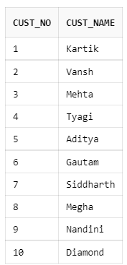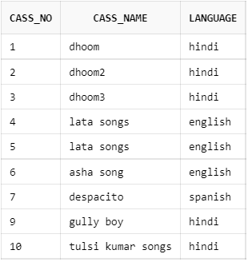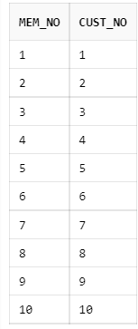

3.List all the customer names with their membership numbers-:

select cust_name,mem_no from customer natural join membership

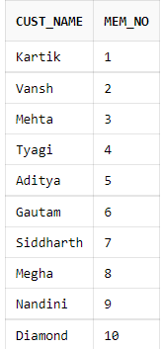

4. List all the issues for the current date with the customer names and cassette names.

select i.iss_no , c.cust_name,cs.cass_name from customer c, membership m , cassette cs , iss_rec i where c.cust_no=m.cust_no and m.mem_no=i.mem_no and cs.cass_no=i.cass_no and i.iss_date=to_char(sysdate);

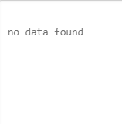

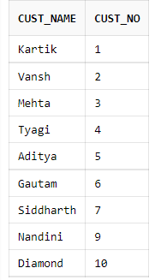5. List the details of the customer who has borrowed the cassette whose title is “lata songs”.

6. Give a count of how many cassettes have been borrowed by each customer.

select s.cust_no, count(i.cass_no) from customer s,membership m, cassette b, iss_reco i where s.cust_no=m.cust_no and b.cass_no=i.cass_no group by s.cust_no ;

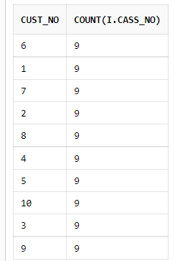

7. Give a list of book which has been taken by the student with mem_no as 5;-

select cass_name from cassette where cass_no in (select cass_no from iss_reco where mem_no in(select mem_no from membership where cust_no in(select cust_no from customer where cust_no=5)));

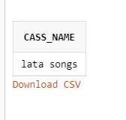

8. List the cassettes issues for today.

select cass_name from cassette where cass_no in (select cass_no from iss_reco

where iss_date=to_char(sysdate));

9. Create a view which lists outs the iss_no, iss_date, cust_name, cass_name.

create view cus_view as select i.iss_no,i.iss_date,c.cust_name,cass_name from customer c,membership m,cassette c,iss_reco i where c.cust_no=m.cust_no and c.cass_no=i.cass_no and m.mem_no=i.mem_no;

select * from cus_view;

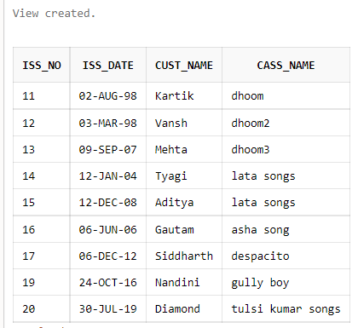

10. Create a view which lists issues-date wise for the last one week.

create view cust_view as select c.cust_no,i.iss_no,c.cust_name,c.cass_name from customer c,membership m,cassette c,iss_reco i where c.cust_no=m.cust_no and c.cass_no=i.cass_no and m.mem_no=i.mem_no and iss_date>=ADD_MONTHS( SYSDATE, -7 );

select * from cust_view;

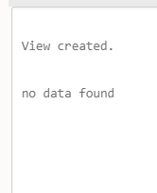

**7.) Database Schema for a student-Lab scenario**

**Student(stud_no: integer, stud_name: string, class: string)**

**Class(class: string, descrip: string)**

**Lab(mach_no: integer, Lab_no: integer, description: String)**

**Allotment(Stud_no: Integer, mach_no: integer, dayof week: string)**

a)create table student(

stud_noint ,

stud_namevarchar2(20),

classes varchar2(20));

desc student;

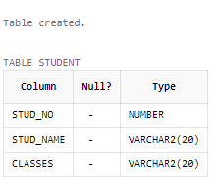

create table classes(

classes varchar2(20) NOT NULL PRIMARY KEY ,

descrip varchar2(20));

desc classes;

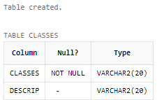

create table lab(

mach_noint NOT NULL PRIMARY KEY ,

lab_noint,

description varchar2(20));

desc lab;

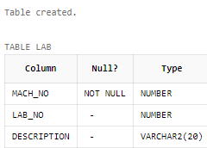

create table allotment(

stud_noint,

mach_noint,

dayofweek varchar2(20));

desc allotment;

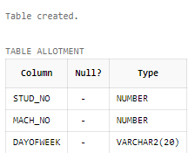

b)insert into student values(1,'Abhijeet',8);

insert into student values(2,'Riyan',8);

insert into student values(3,'Ronak',12);

insert into student values(4,'Manshi',9);

insert into student values(5,'Manisha',7);

insert into student values(6,'Akansha',10);

insert into student values(7,'Aditya',11);

insert into student values(8,'Anshul',11);

insert into student values(9,'Shreya',10);

insert into student values(10,'Ravindra',10);

Select* from student;

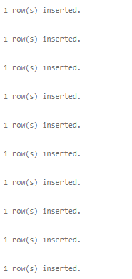

insert into classes values(1,'first floor');

insert into classes values(2,'second floor');

insert into classes values(3,'third floor');

insert into classes values(4,'first floor');

insert into classes values(5,'second floor');

insert into classes values(6,'first floor');

insert into classes values(7,'third floor');

insert into classes values(8,'first floor');

insert into classes values(9,'second floor');

insert into classes values(10,'first floor');

insert into classes values(11,'first floor');

insert into classes values(12,'first floor');

Select * from classes;

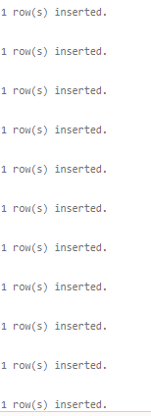

insert into lab values( 11,1,'basement');

insert into lab values( 12,2,'basement');

insert into lab values( 13,3,'basement');

insert into lab values( 14,4,'first floor');

insert into lab values( 15,5,'basement');

insert into lab values( 16,6,'third floor');

insert into lab values( 17,7,'basement');

insert into lab values( 18,8,'basement');

insert into lab values( 19,9,'second floor');

insert into lab values( 20,10,'basement');

Select * from lab;

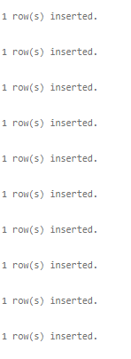

insert into allotment values(9,12,'monday');

insert into allotment values(7,18,'friday');

insert into allotment values(9,17,'tuesday');

insert into allotment values(8,11,'wednesday');

insert into allotment values(1,12,'monday');

insert into allotment values(5,17,'thursay');

insert into allotment values(6,15,'monday');

insert into allotment values(10,12,'wednesday');

insert into allotment values(1,11,'tuesday');

insert into allotment values(2,20,'monday');

Select * from lab;

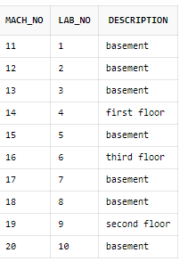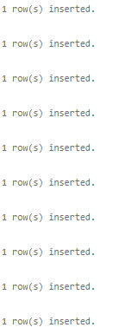

c) Select stud_name,lab_no,mach_no from student NAtural Join lab NAtural Join allotment;

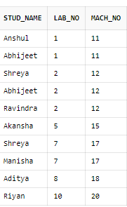

d) Select allotment.dayofweek,count(lab.lab_no)as count from allotment,lab where lab.mach_no=allotment.mach_no group by allotment.dayofweek;

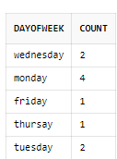

e)Select count(lab_no)as count from student NAtural JOIN classes NAtural JOIN lab NAtural JOIN allotment where classes=10;

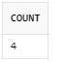

f) select * from student Natural JOIN classes Natural join allotment where stud_no=5;

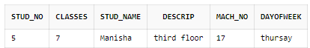

g) Select count(mach_no) from lab Natural join allotment where lab_no=2 and dayofweek='monday';

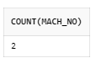

h) Select student.classes,count(allotment.mach_no)as count from allotment,lab,student where lab.mach_no=allotment.mach_no and student.stud_no=allotment.stud_no group by student.classes;

